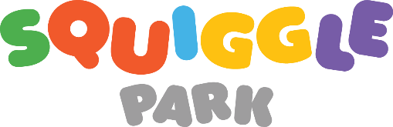
We are so excited to share this reading skills program with you that has been proven to predictably improve English reading skills 5x faster than with traditional instruction alone.

Squiggle Park is a game used in classrooms and at home where kids play through worlds and levels all filled with content carefully designed to help them master English. The games are fun for kids and designed to be played independently making it easy for parents.

We are excited for your child to start building their skills to be confident readers through play!

To Start Playing
Have your codes ready.

On the web:

- Go to the homepage at www.squigglepark.com and select Squiggle Park on the left side
- Make sure you are at squigglepark.com/squigglepark and click on the STUDENT PLAY button in the top right corner
- Log in using the grey 5 digit code and 4 digit code
- Make sure your volume is on and start playing!

On phones or tablets:

- Download the app from the iTunes store: https://itunes.apple.com/app/id1077048621 or Google Play Store https://play.google.com/store/apps/developer?id=Squiggle+Park
- Open the app and press the orange play button
- Select ‘School Account’
- Log in using the grey 5 digit code and 4 digit code
- Make sure your volume is on and start playing!

Tips & Tech
- Studies have shown improvements in reading skill development with a minimum of only 30 minutes of play each week.
- Squiggle Park requires an internet connection to play.
- The best web experience on a Mac or PC is using Chrome or Firefox.
Support
- Click Support on squigglepark.com/squigglepark to submit a support ticket or read our Frequently Asked Questions
- Call for support at 1-866-599-7540 (toll free)
Email us support@squigglepark.com

